__________’s Chores

Monday | Tuesday | Wednesday | Thursday | Friday
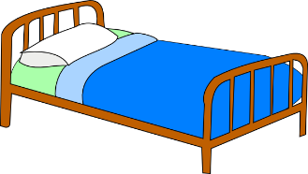  Sheets | Hampers   | Bathroom   | Sweep/Mop  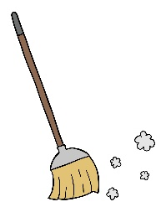 | Trashes  

__________’s Chores
Monday | Tuesday | Wednesday | Thursday | Friday
Sheets  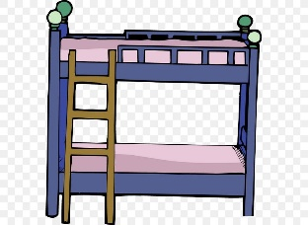 | Trashes | Bathroom | Sweep/Mop | Hampers

